**PROJECT-12**

**GEOMETRIC MEAN**

**FILTER**

EE5356 Digital Image Processing

Dr. K. R. Rao

Submitted By:

Ashutosh Desai

UTA ID:1001388602

Email: - ashutoshrajesh.desai@mavs.uta.edu

SPRING-2018

QUESTION

Geometric Mean Filter

1) For the degraded images given in project#7 Inverse and Wiener Filtering, apply the geometric mean filter for  and show the restored images.

For , GMF is described by Eq. (8.71) /p.291

2) Repeat prob. 1) for 

3) Repeat prob. 1) for 

Comment on the restored images.

(Hint : for s=0, GMF  Wiener filter, for s=1, GMF Inverse filter)

$G_{j}={(H^{-})}^{j}{\left[\frac{S_{uu}H^{*}}{S_{uu}{|H|}^{2}+S_{nn}}\right]}^{1-j}$ (8.70)

GMF

For j=1/2

$G_{1/2}={\left[\frac{S_{uu}}{S_{uu}{\left|H\right|}^{2}+S_{nn}}\right]}^{1/2}{(H∙H^{-})}^{1/2}exp⁡(-jθ_{H})$ (8.71)

$θ_{H}(ω_{1},ω_{2})$ is phase of H($ω_{1},ω_{2}$)

**THEORY**

The geometric mean filter is member of a set of nonlinear mean filters which are better at removing Gaussian type noise and preserving edge features than the arithmetic mean filter. The geometric mean filter is very susceptible to negative outliers

This function will filter the image by the nonlinear geometric mean method. This function works for only monochrome, 8 bit per bixel and 24 bit per pixel images. The geometric mean filter is member of a set of nonlinear mean filters which are better at removing Gaussian type noise and preserving edge features than the arithmetic mean filter. The geometric mean filter is very susceptible to negative outliers. The definition of  geometric mean filter is :

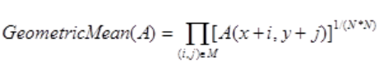

In the geometric mean method, the color value of each pixel is replaced with the geometric mean of color values of the pixels in a surrounding region. A larger region (filter size) yields a stronger filter effect with the drawback of some blurring.

The geometric mean is defined as:



this filter is combination of Wiener and Least Square. So the quality of image obtained after restoration is much higher compared to other filters.

Moreover as we change the value of “s”, the quality of image also changes. As the value of “s” increases, the image becomes more clear after restoration i.e. the quality increases.

**MATLAB SCRIPT:**

clc;

clear all ;

close all ;

%Original image

Img = double(imread('D:\STUDY\DIP\Test img\lena512.bmp'));

[Row Column] = size(Img);

Input_Image_Fourier = fft2(Img);

[a,b] = meshgrid(1:Row,1:Column);

%Blur Function.

Blur_Funct_1 = exp(-0.0025*(a.^2+b.^2).^(5/6));

Blur_Funct_2 = exp(-0.001*(a.^2+b.^2).^(5/6));

Blur_Funct_3 = exp(-0.00025*(a.^2+b.^2).^(5/6));

%Noise

Noise = randn(Row,Column);

Noise_Fourier = fft2(Noise);

%Blurred images.

Blurred_Img_1 = Input_Image_Fourier.*Blur_Funct_1;

Blurred_Img_2 = Input_Image_Fourier.*Blur_Funct_2;

Blurred_Img_3 = Input_Image_Fourier.*Blur_Funct_3;

%Blurred and Noisy image

Total_Distortion1 = Blurred_Img_1 + Noise_Fourier;

Total_Distortion2 = Blurred_Img_2 + Noise_Fourier;

Total_Distortion3 = Blurred_Img_3 + Noise_Fourier;

Img_1 = abs(ifft2(Blurred_Img_1));

Img_2 = abs(ifft2(Blurred_Img_2));

Img_3 = abs(ifft2(Blurred_Img_3));

subplot(2,3,1);

imshow(uint8(Img_1));

title(' Blurred Image K=0.0025')

subplot(2,3,2);

imshow(uint8(Img_2));

title(' Blurred Image K=0.001')

subplot(2,3,3);

imshow(uint8(Img_3));

title(' Blurred Image K=0.000025')

Noisy_Image_Recovered1 = abs( ifft2(Total_Distortion1));

Noisy_Image_Recovered2 = abs( ifft2(Total_Distortion2));

Noisy_Image_Recovered3 = abs( ifft2(Total_Distortion3));

Weiner_Filt_1 = wiener2(Noisy_Image_Recovered1,[3 3],Noise);

Weiner_Filt_2 = wiener2(Noisy_Image_Recovered2,[3 3],Noise);

Weiner_Filt_3 = wiener2(Noisy_Image_Recovered3,[3 3],Noise);

%Geometric Mean filter

s=1/2;

Funct_1=((Blur_Funct_1^s).*((Weiner_Filt_1).^(1-s)));

Funct_1_a=Total_Distortion1.*Funct_1;

Final_Image_1=ifft2(ifftshift(Funct_1_a));

subplot(2,3,4);

imagesc((abs(Final_Image_1)));

title(' S=1/2,K=0.0025');

Funct_1_1=((Blur_Funct_2^s).*((Weiner_Filt_2).^(1-s)));

Funct_1_b=Total_Distortion2.*Funct_1_1;

Final_Image_2=ifft2(ifftshift(Funct_1_b));

subplot(2,3,5);

imagesc((abs(Final_Image_2)));

title(' S=1/2,K=0.001');

Funct_1_2=((Blur_Funct_3^s).*((Weiner_Filt_3).^(1-s)));

Funct_1_c=Total_Distortion3.*Funct_1_2;

Final_Image_3=ifft2(ifftshift(Funct_1_c));

subplot(2,3,6);

imagesc((abs(Final_Image_3)));

title(' S=1/2,K=0.000025');

figure;

s=1/4;

Funct_2=((Blur_Funct_1^s).*((Weiner_Filt_1).^(1-s)));

Funct_2_a=Total_Distortion1.*Funct_2;

Final_Image_4=ifft2(ifftshift(Funct_2_a));

subplot(2,2,1);

imagesc((abs(Final_Image_4)));

colormap(gray);

title(' S=1/4,K=0.0025');

Function2_1=((Blur_Funct_2^s).*((Weiner_Filt_2).^(1-s)));

Funct_2_b=Total_Distortion2.*Function2_1;

Final_Image_5=ifft2(ifftshift(Funct_2_b));

subplot(2,2,2);

imagesc((abs(Final_Image_5)));

colormap(gray);

title(' S=1/4,K=0.001');

Funct_2_2=((Blur_Funct_3^s).*((Weiner_Filt_3).^(1-s)));

Funct_2_c=Total_Distortion3.*Funct_2_2;

Final_Image_6=ifft2(ifftshift(Funct_2_c));

subplot(2,2,3);

imagesc((abs(Final_Image_6)));

colormap(gray);

title(' S=1/4,K=0.000025');

figure;

s=3/4;

Funct_3=((Blur_Funct_1^s).*((Weiner_Filt_1).^(1-s)));

Funct_3_a=Total_Distortion1.*Funct_3;

Final_Image_7=ifft2(ifftshift(Funct_3_a));

subplot(2,2,1);

imagesc((abs(Final_Image_7)));

colormap(gray);

title(' S=3/4,K=0.0025');

Funct_3_1=((Blur_Funct_2^s).*((Weiner_Filt_2).^(1-s)));

Funct_3_b=Total_Distortion2.*Funct_3_1;

Final_Image_8=ifft2(ifftshift(Funct_3_b));

subplot(2,2,2);

imagesc((abs(Final_Image_8)));

colormap(gray);

title(' S=3/4,K=0.001');

Funct_3_2=((Blur_Funct_3^s).*((Weiner_Filt_3).^(1-s)));

Funct_3_c=Total_Distortion3.*Funct_3_2;

Final_Image_9=ifft2(ifftshift(Funct_3_c));

subplot(2,2,3);

imagesc((abs(Final_Image_9)));

colormap(gray);

title(' S=3/4,K=0.000025');

**OUTPUT:**

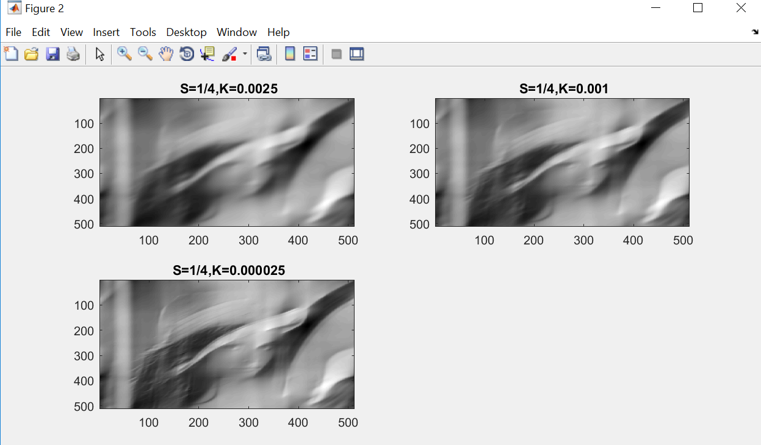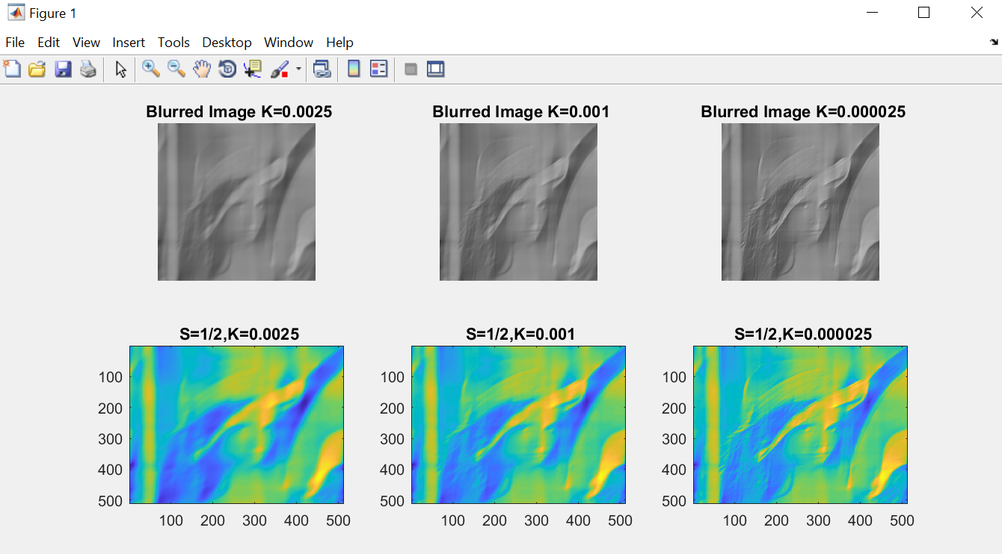

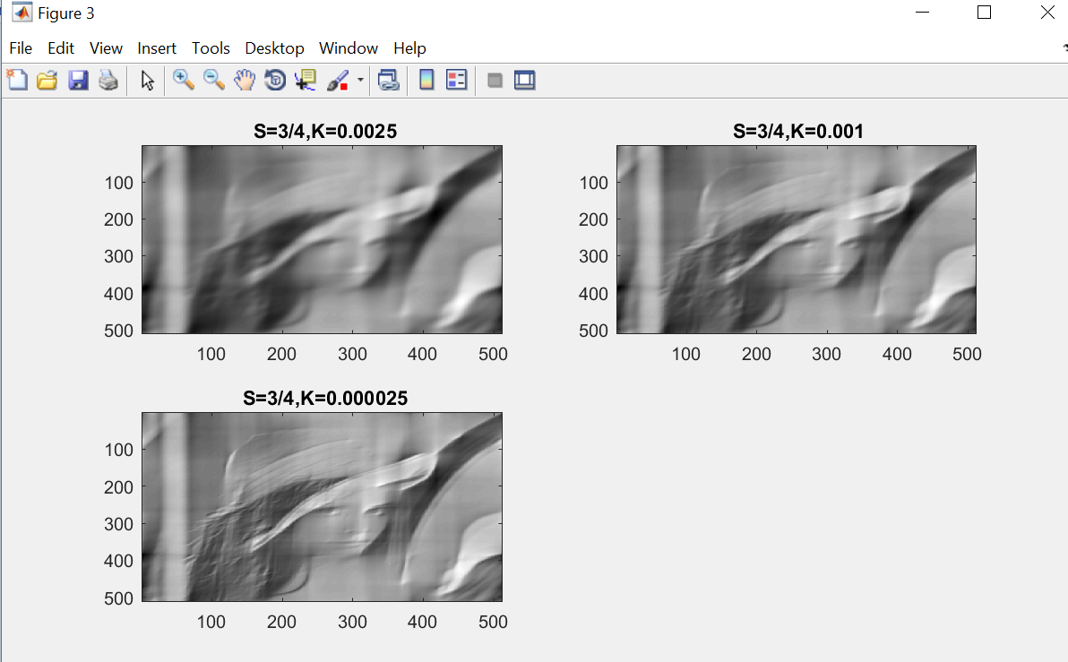

**CONCLUSION:**

From this experiment we observed the effects of “Geometric Mean Filter” on the images. So from the images we can see that this filter is combination of Wiener and Least Square. So the quality of image obtained after restoration is much higher compared to other filters.

Moreover as we change the value of “s”, the quality of image also changes. As the value of “s” increases, the image becomes more clear after restoration i.e. the quality increases.